**PAS**

**To:** Dr. Matt Bohm

**From:** PAS

**Project:** Plasma Arc Speaker

**Subject:** Concept Variant 5

**Date:** March 4, 2011

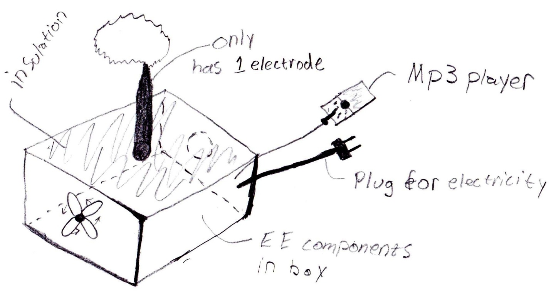

CV 5 has one electrode. The box below the electrode houses the electrical components.  Using only one electrode will require a much higher voltage.  Increasing the voltage also increases the heat generation. A fan is required to remove the heat from the system to keep the temperature in a safe working condition.